

CSA0902-Programming in Java

CO3 - AT1

Debugging and Optimization Task

Ashmi P S
192571004

- Arithmetic Exception Handling
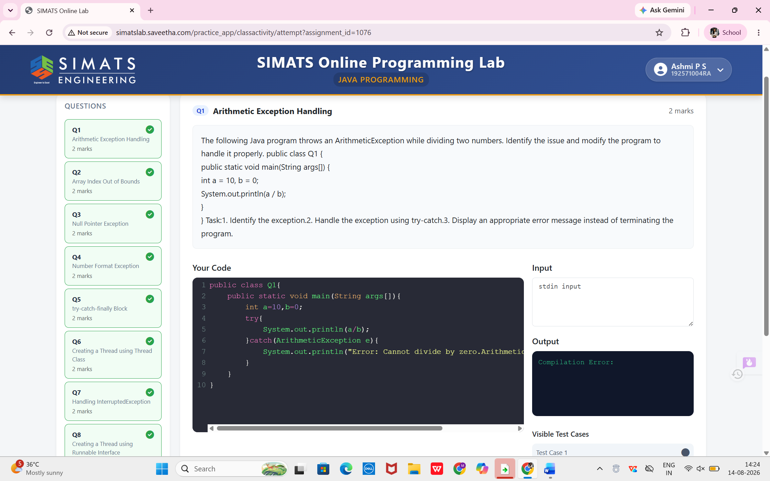

- Array Index Out of Bounds
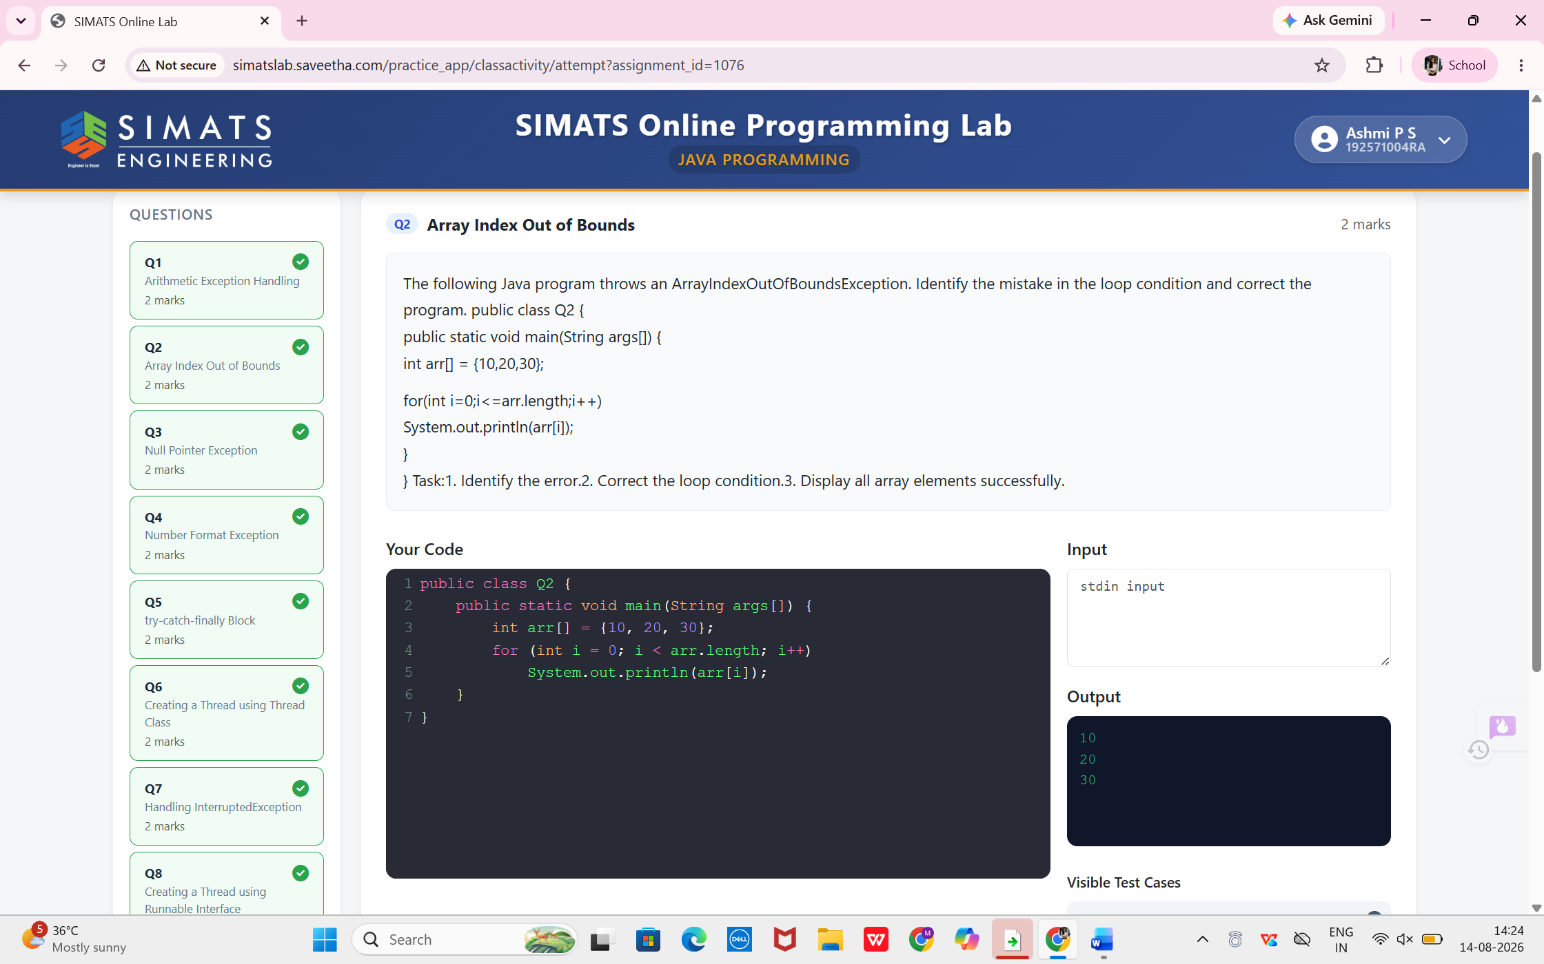
- Null Pointer Exception
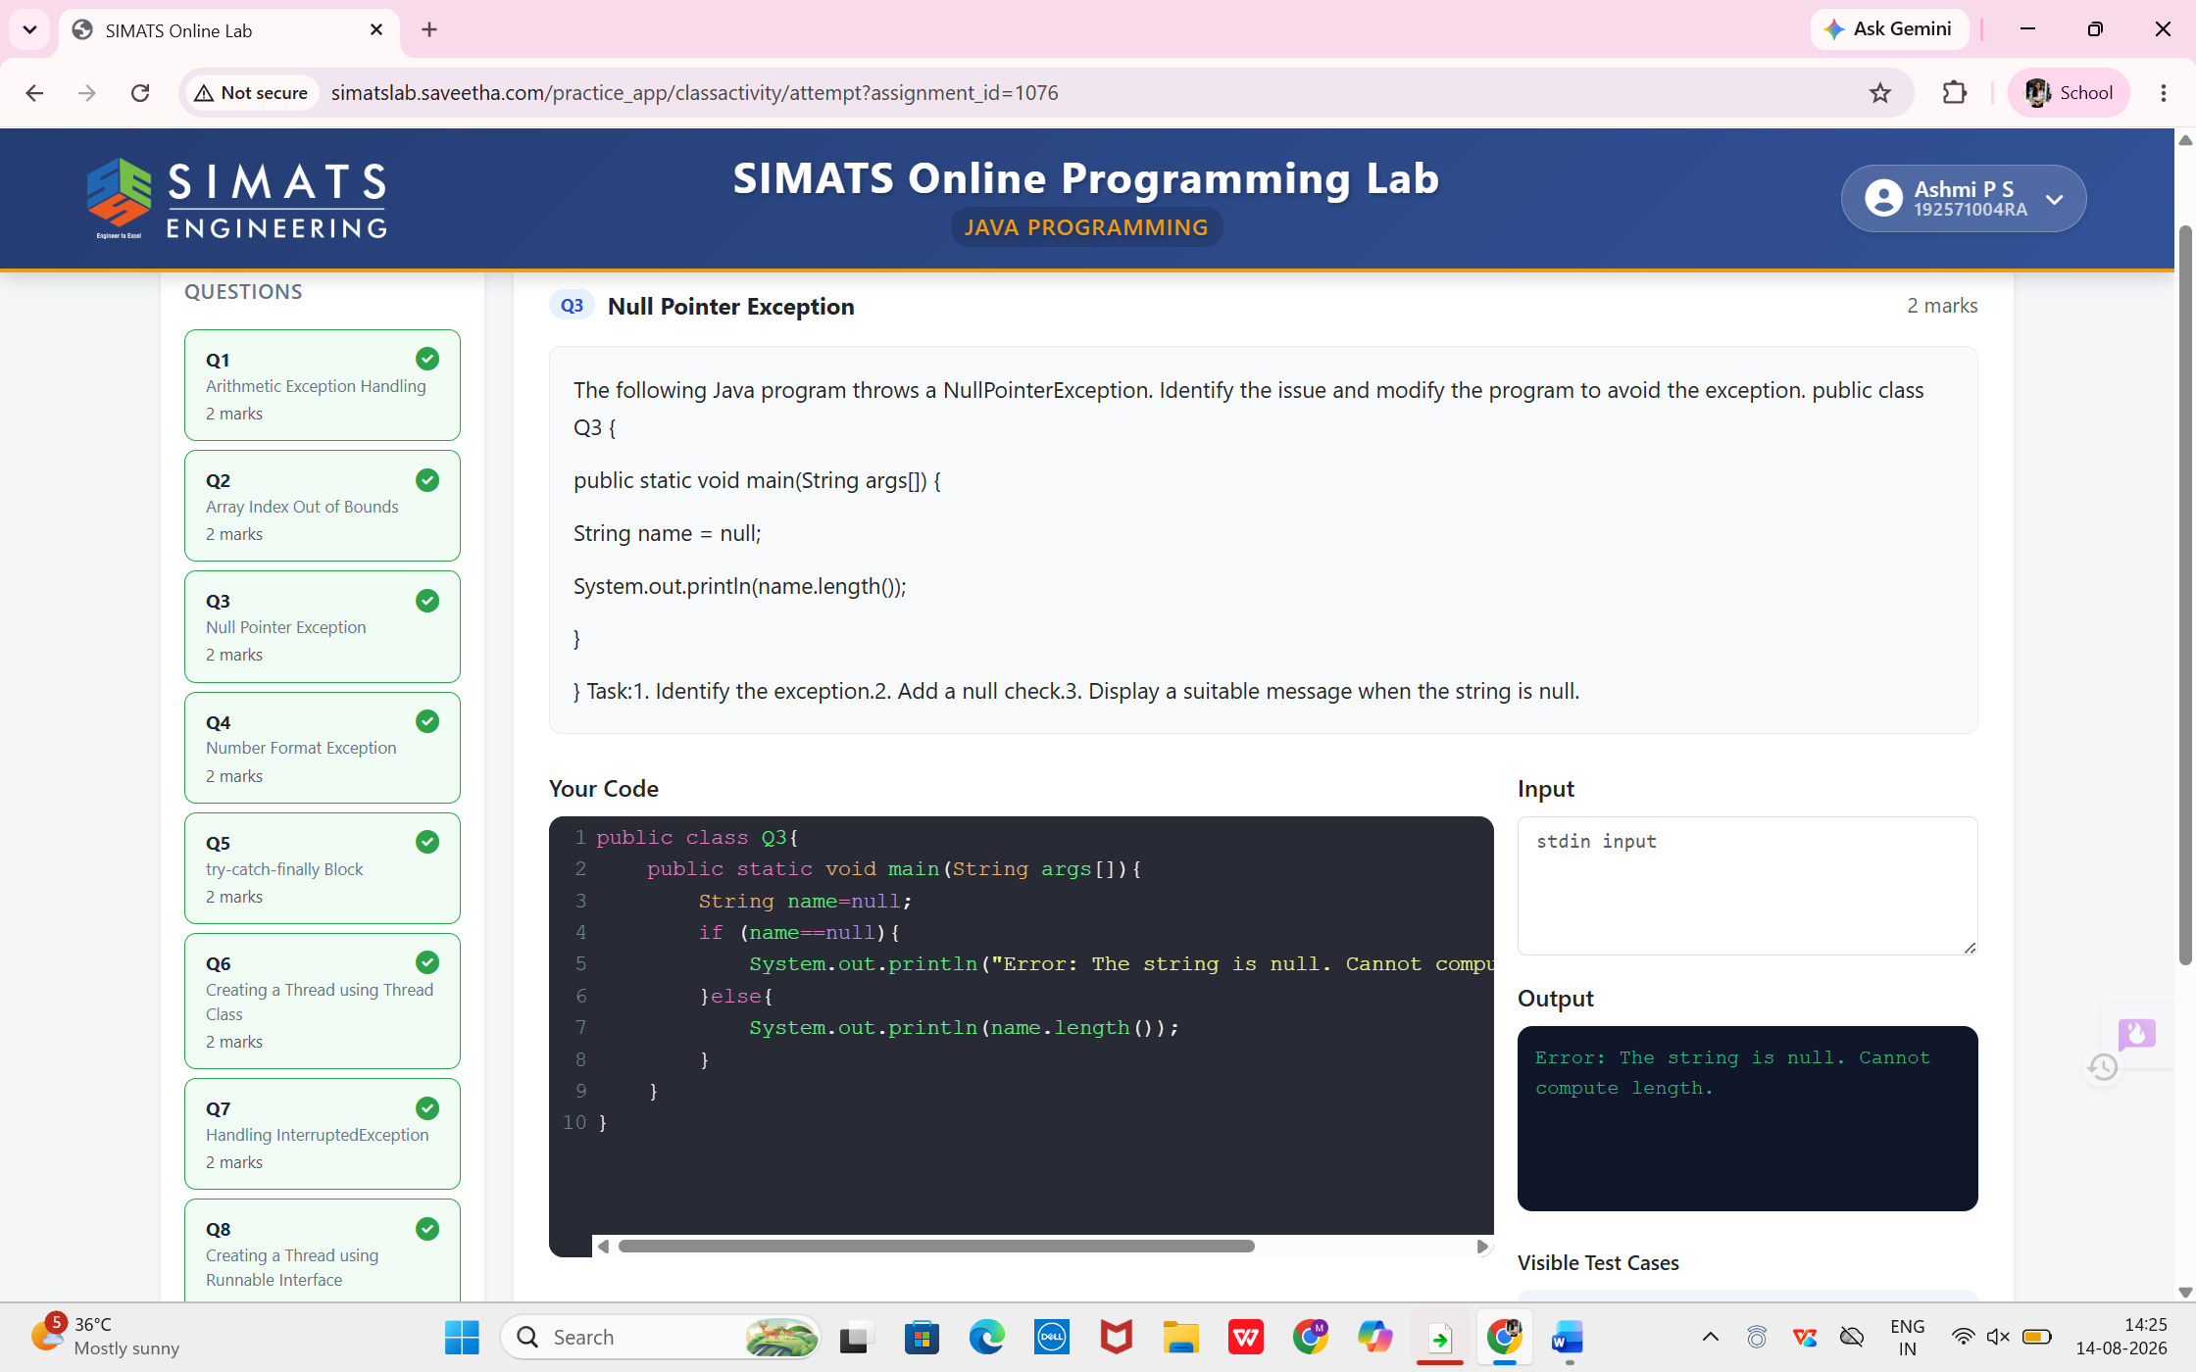

- Number Format Exception
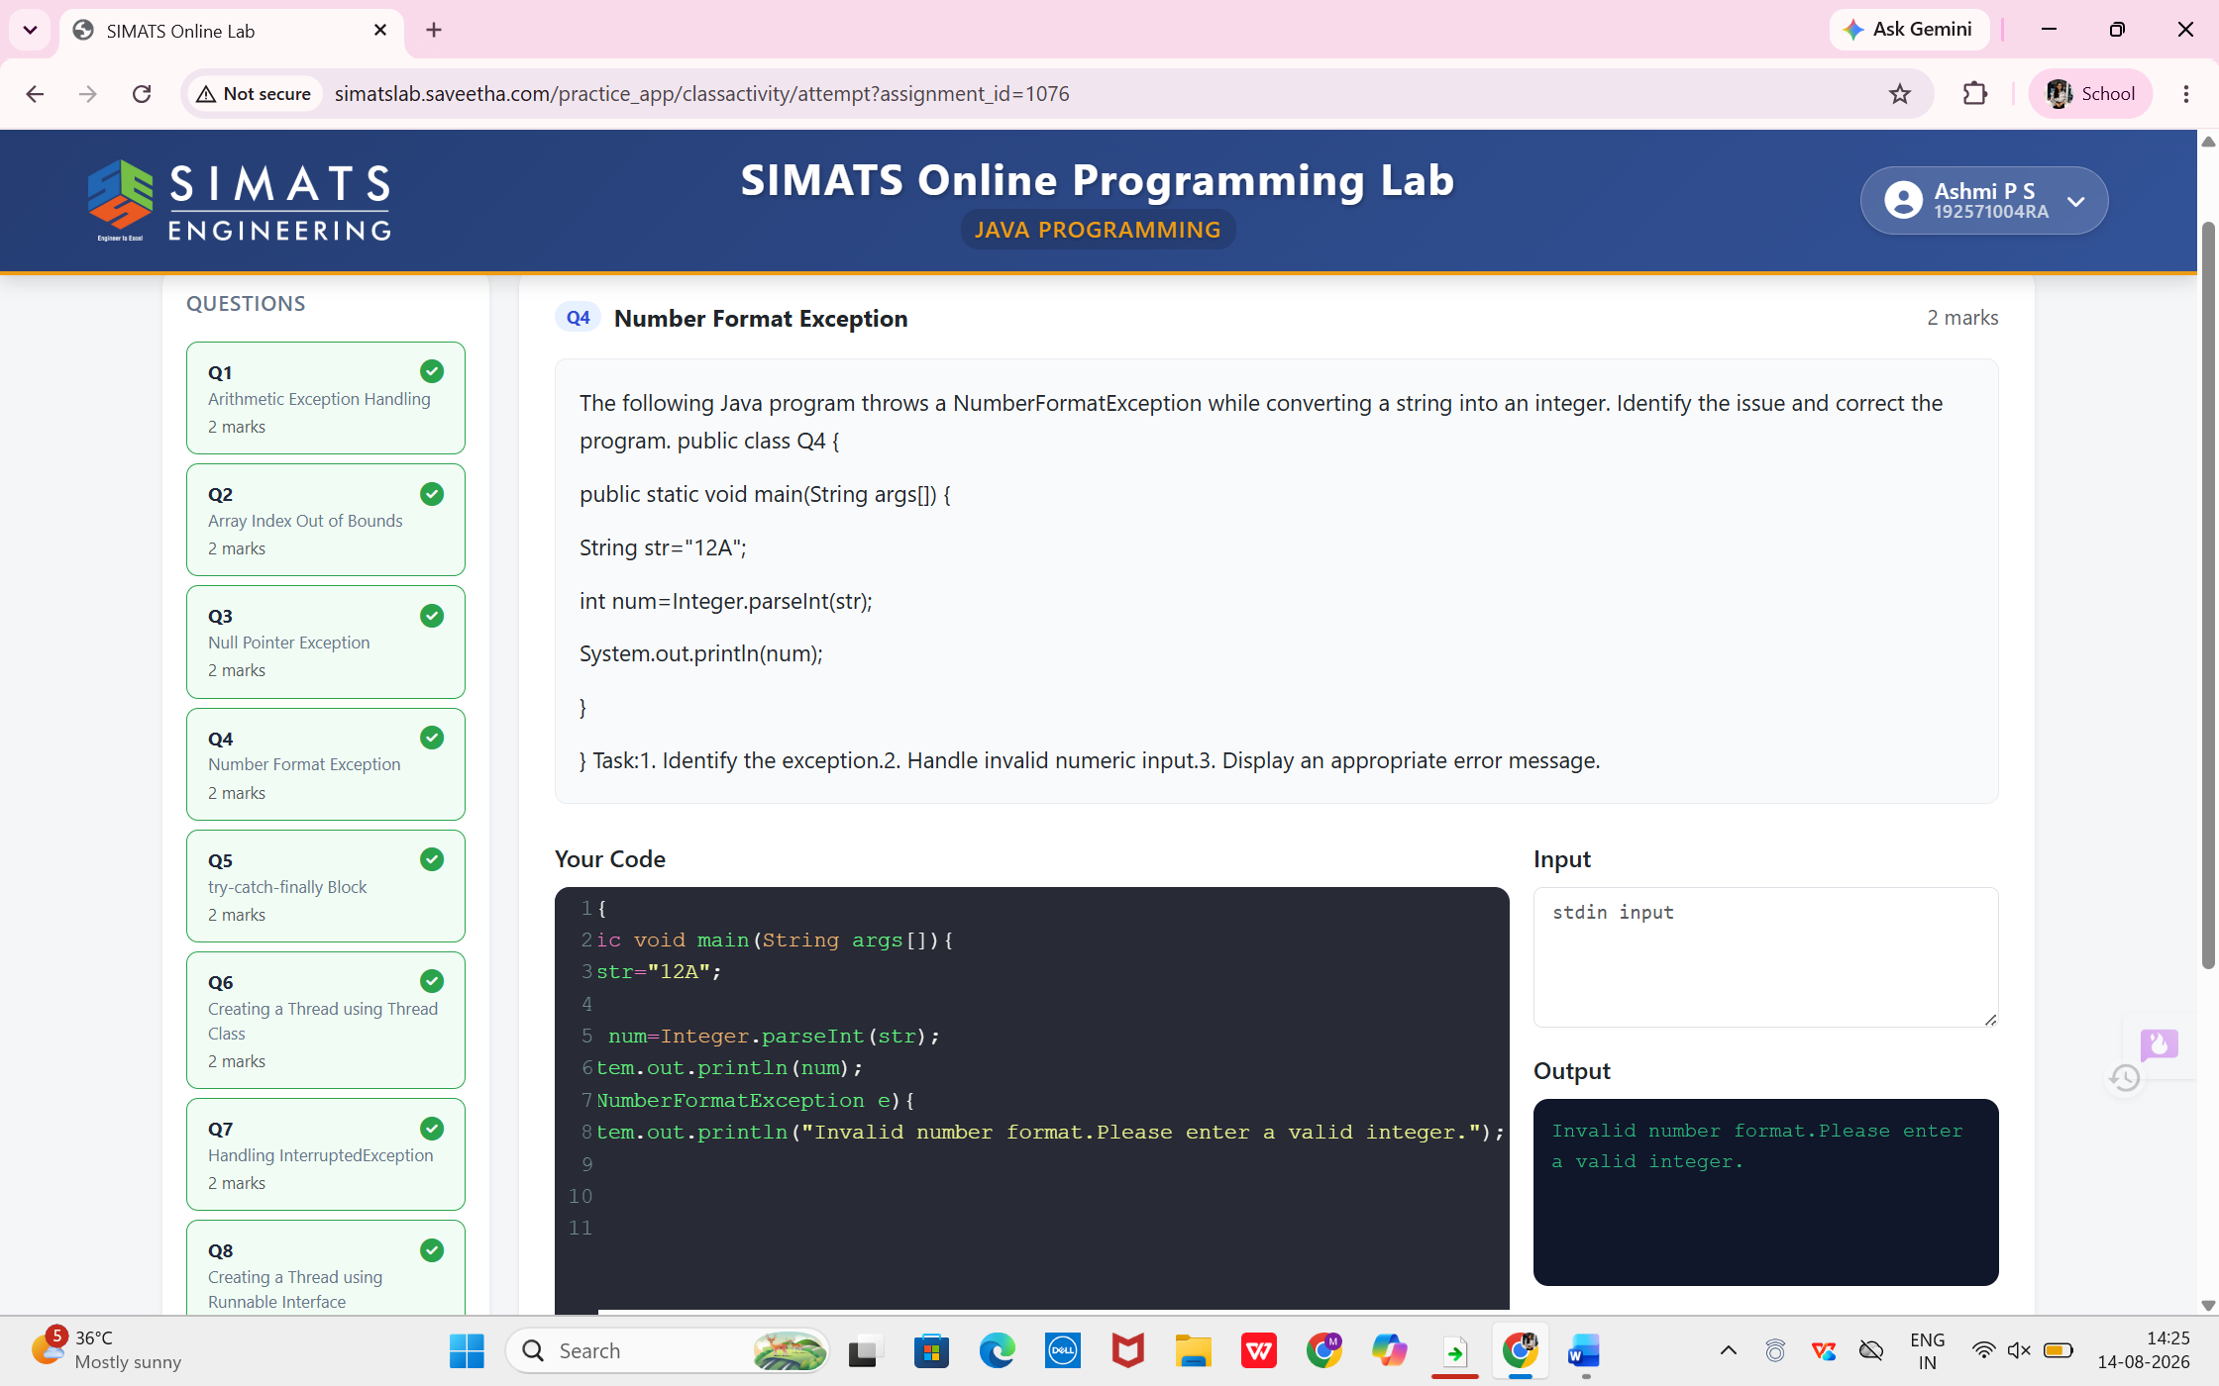

- try-catch-finally Block
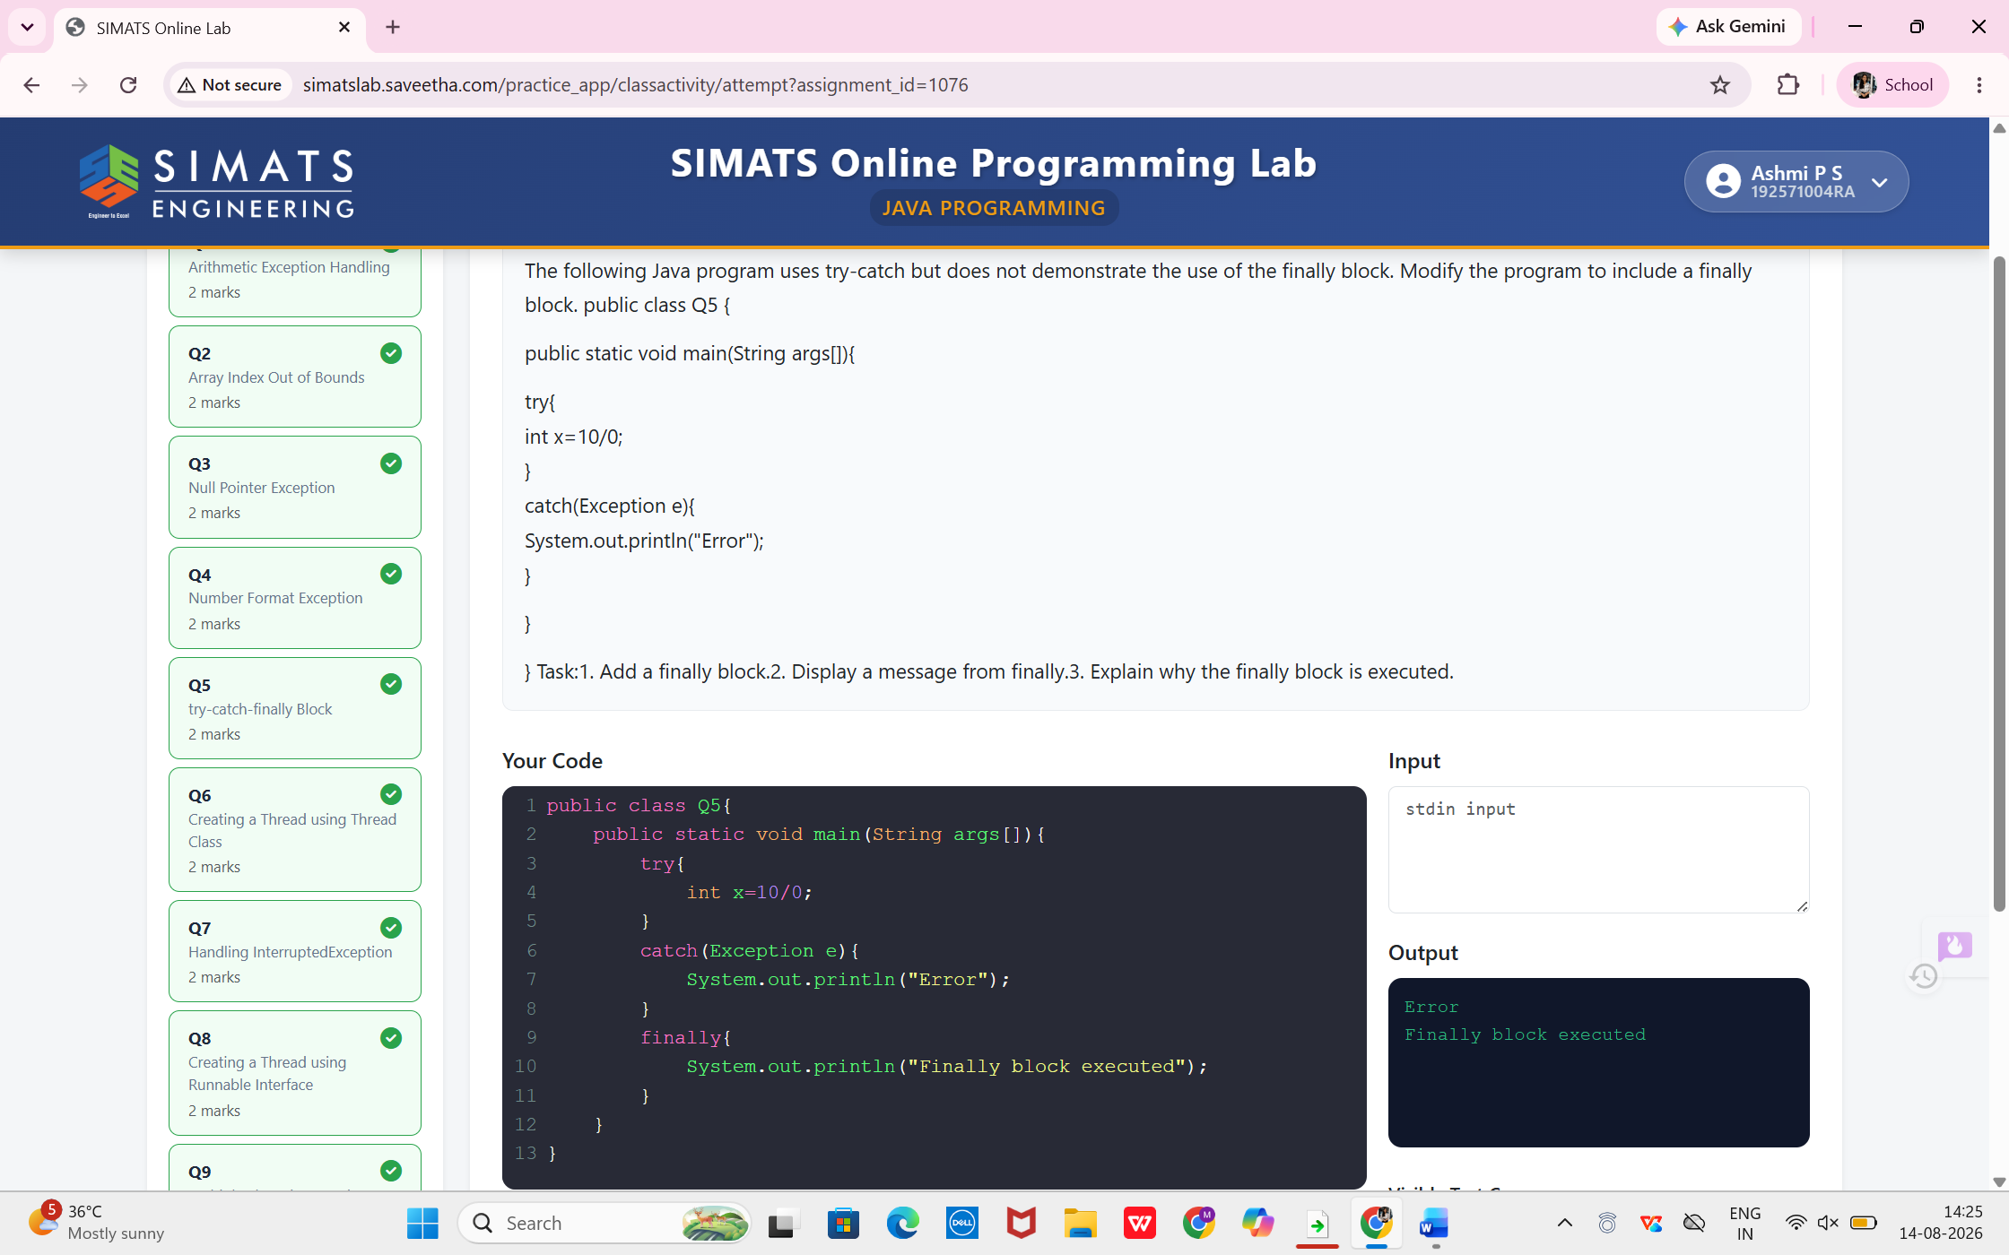

6. Creating a Thread Class
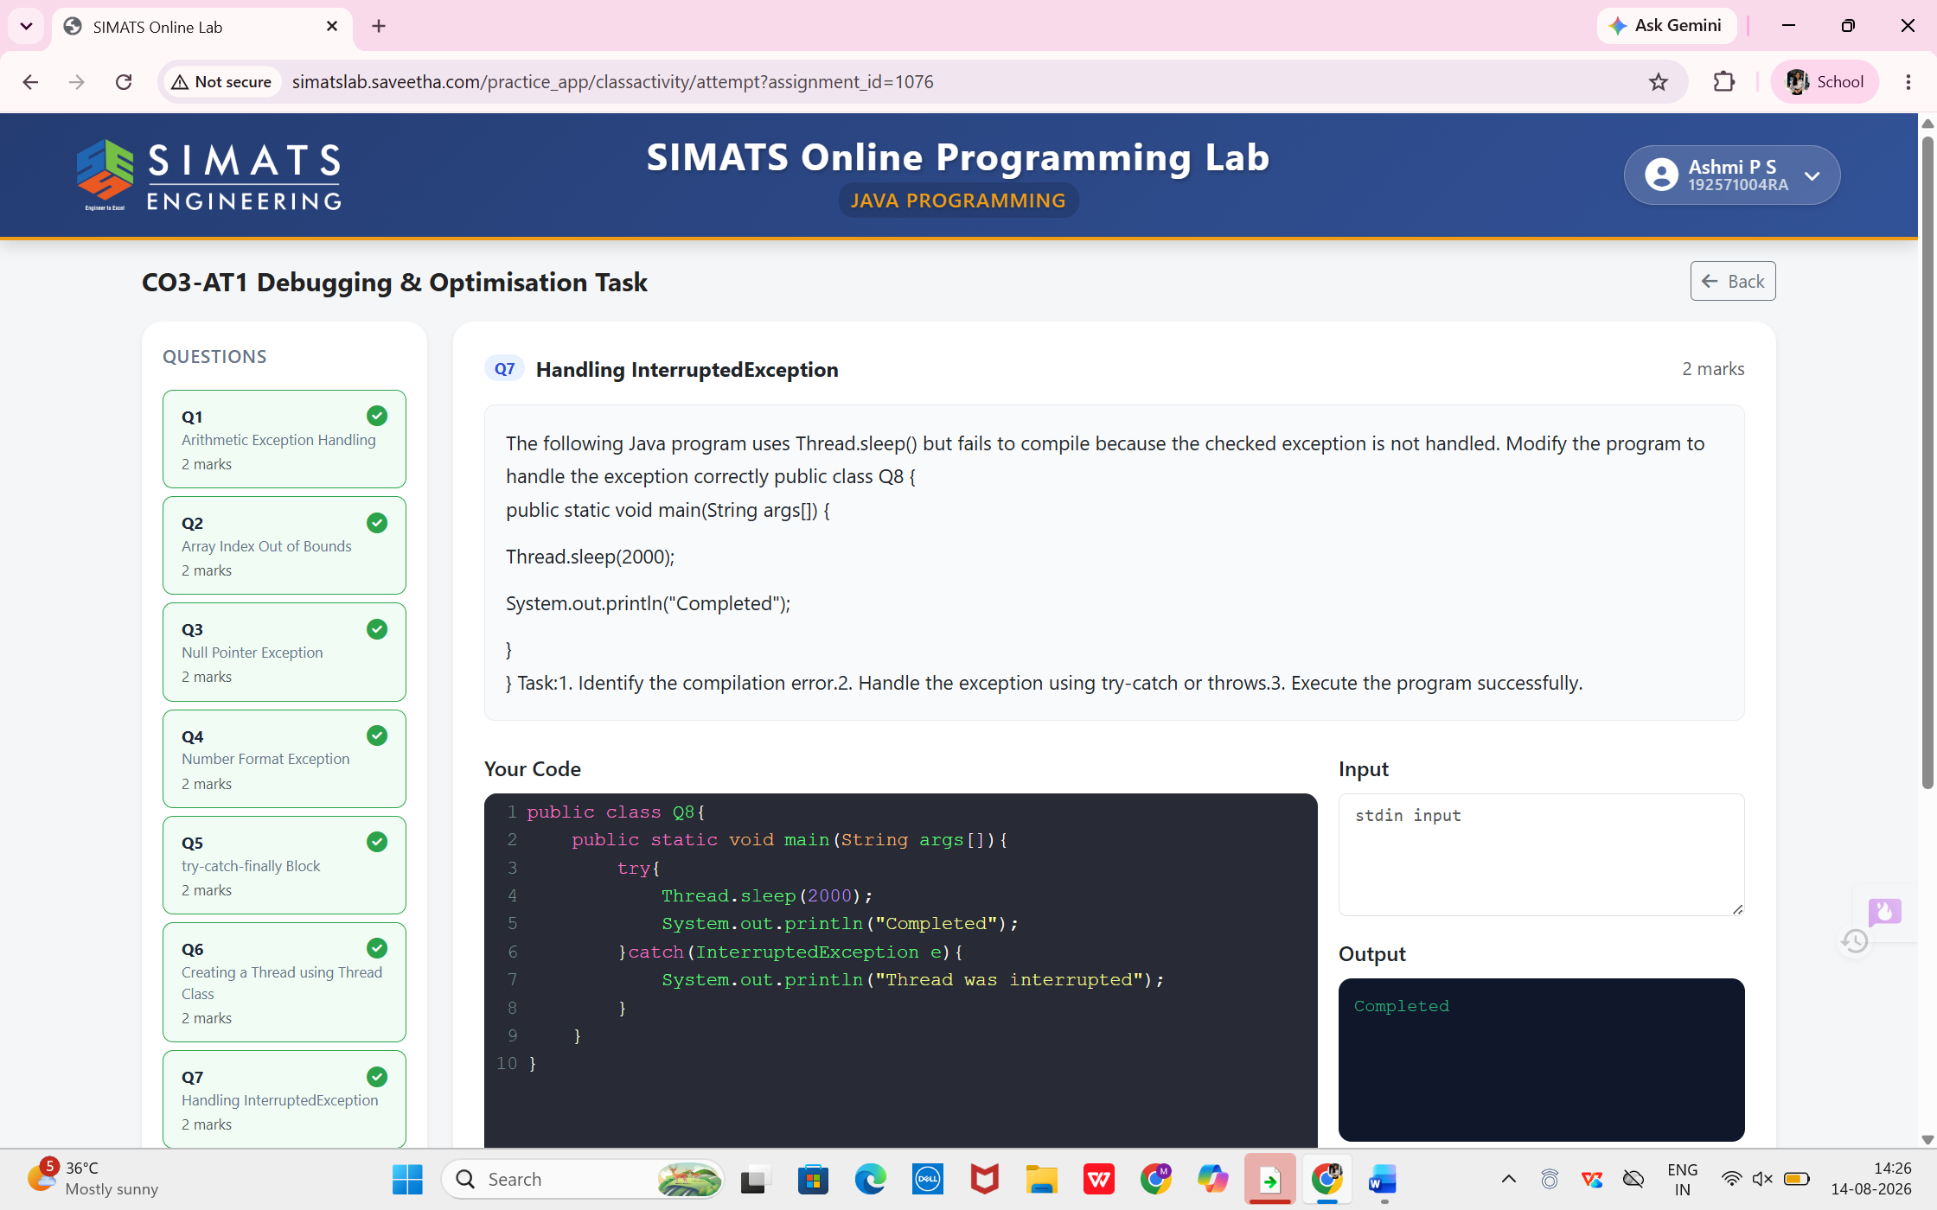
7. Handling Interrupt Exception
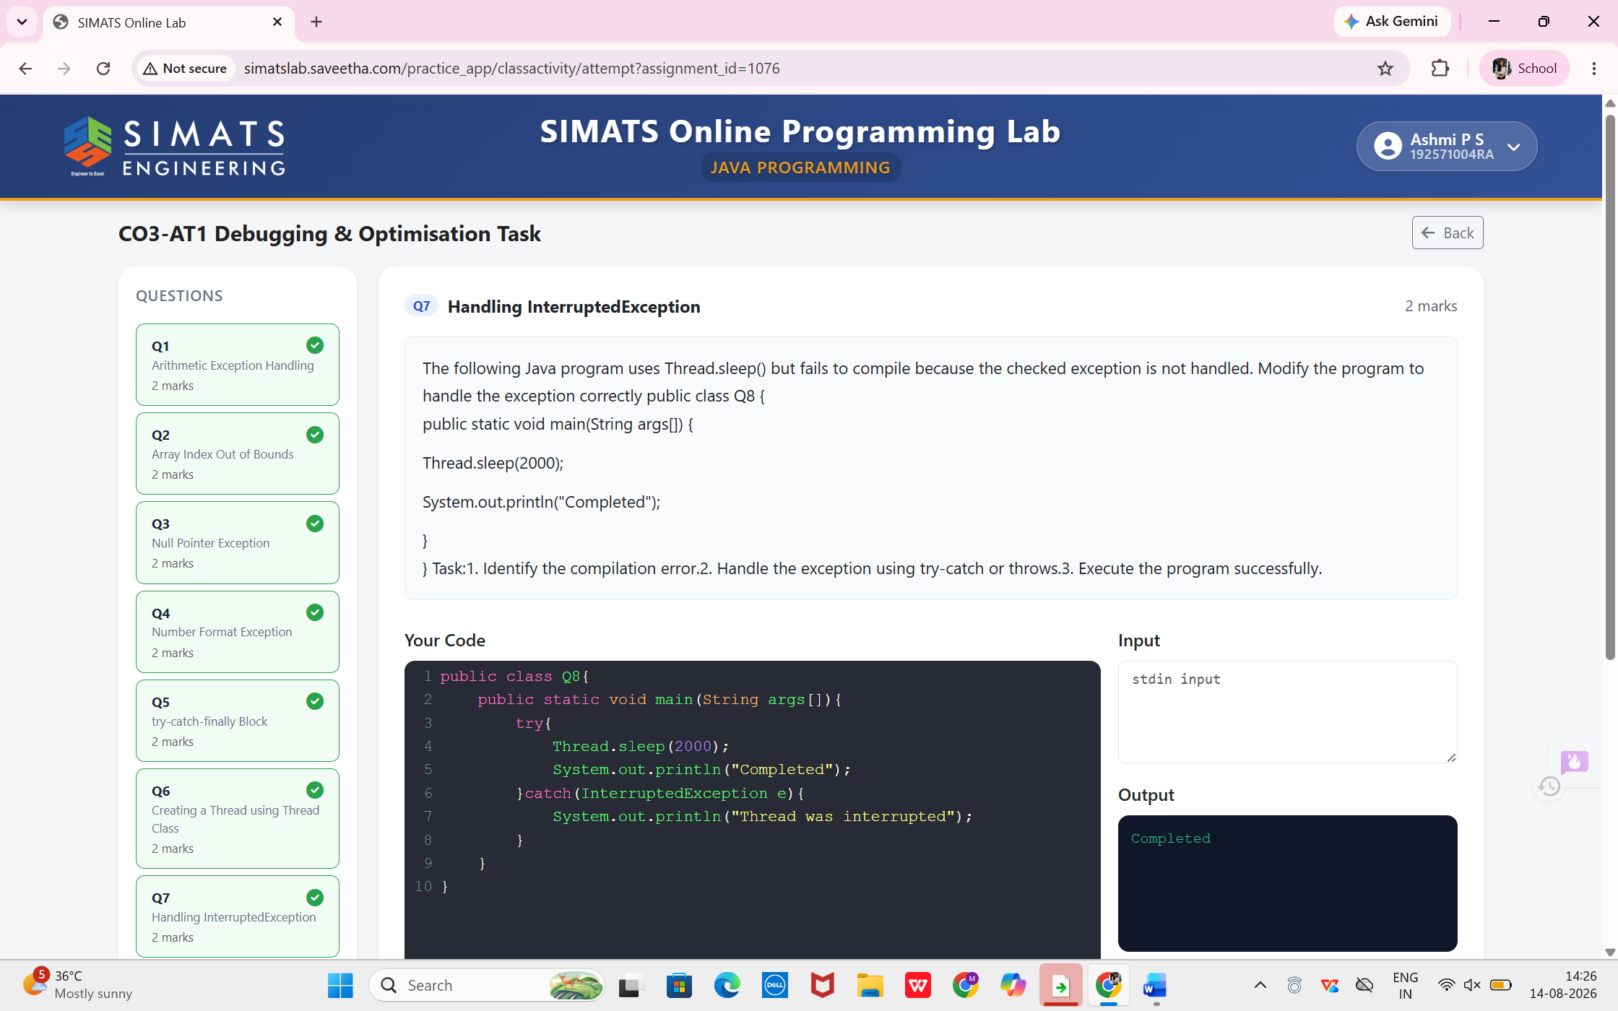

8.Creating a Thread using Runnable Inerface
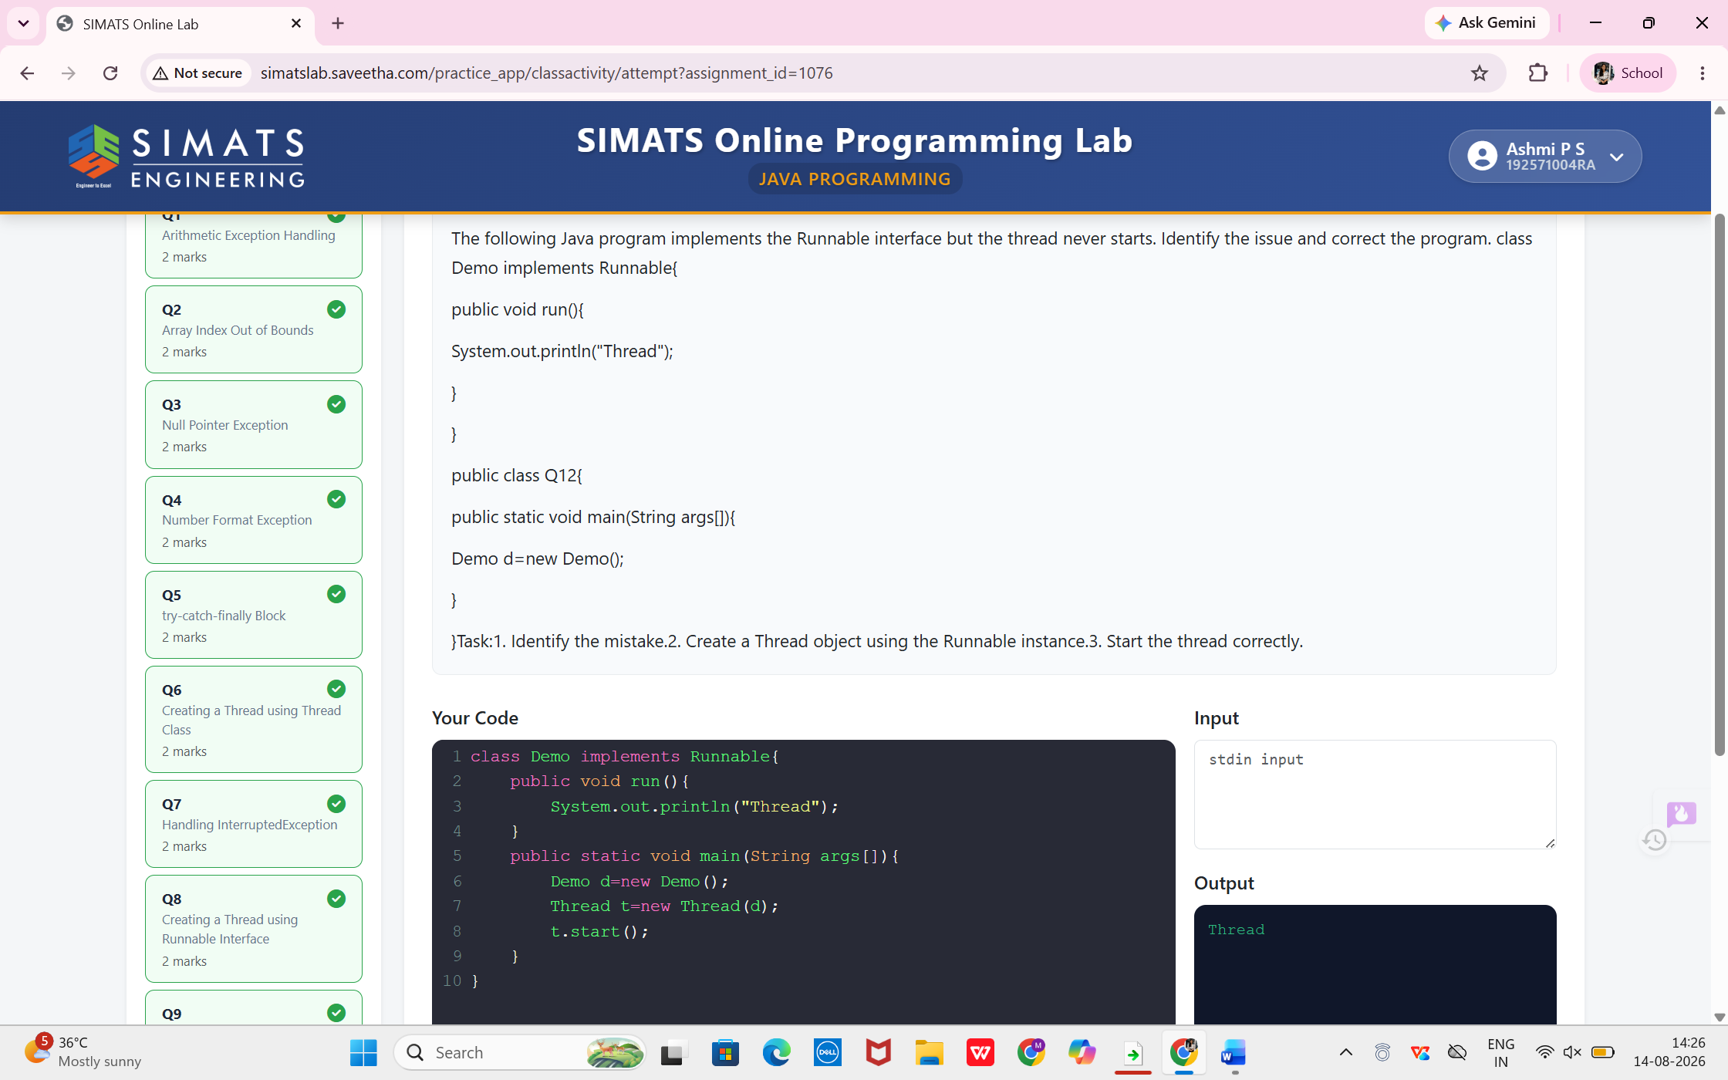
- Multiple Threads Execution
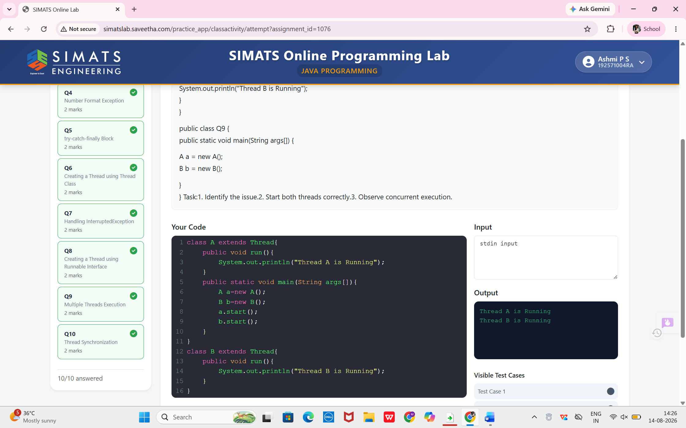

- Thread Synchronization
